Problem 1

**package** Prob1;

**import** java.util.*;

**public** **class** Admin {

**public** **static** HashMap<Key, Student> processStudents(List<Student> students)

{

HashMap<Key, Student> result= **new** HashMap<Key, Student>();

**for** (Student student : students) {

Key key= **new** Key(student.getFirstName(), student.getLastName());

result.put(key, student);

}

**return** result;

}

}

**package** Prob1;

**public** **class** Key {

**private** String firstName;

**private** String lastName;

**public** String getFirstName() {

**return** firstName;

}

**public** String getLastName() {

**return** lastName;

}

**public** Key(String f, String l) {

**this**.firstName = f;

**this**.lastName = l;

}

@Override

**public** **boolean** equals(Object obj) {

**if** (**this** == obj) {

**return** **true**;

}

**if** (obj == **null**) {

**return** **false**;

}

**if** (getClass() != obj.getClass()) {

**return** **false**;

}

Key other = (Key) obj;

**if** (firstName == **null**) {

**if** (other.firstName != **null**)

**return** **false**;

}

**if** (lastName == **null**) {

**if** (other.lastName != **null**)

**return** **false**;

}

**return** firstName.equals(other.firstName) && lastName.equals(other.lastName);

}

@Override

**public** **int** hashCode() {

**final** **int** prime = 31;

**int** result = 1;

result = prime * result + ((firstName == **null**) ? 0 : firstName.hashCode());

result = prime * result + ((lastName == **null**) ? 0 : lastName.hashCode());

**return** result;

}

}

**package** Prob1;

**public** **class** Student {

**private** String firstName;

**private** String lastName;

**private** **double** gpa;

**private** Standing standing;

**public** Student(String firstName, String lastName, **double** gpa, Standing standing) {

**this**.firstName = firstName;

**this**.lastName = lastName;

**this**.gpa=gpa;

**this**.standing = standing;

}

**public** Standing getStanding() {

**return** standing;

}

**public** **double** getGpa() {

**return** gpa;

}

**public** String getFirstName() {

**return** firstName;

}

**public** String getLastName() {

**return** lastName;

}

@Override

**public** String toString() {

**return** "[" + firstName + " " + lastName + "]";

}

@Override

**public** **boolean** equals(Object ob) {

**if**(ob == **null**) **return** **false**;

**if**(ob.getClass() != Student.**class**) **return** **false**;

Student s = (Student)ob;

**return** s.firstName.equals(firstName) && s.lastName.equals(lastName);

}

}

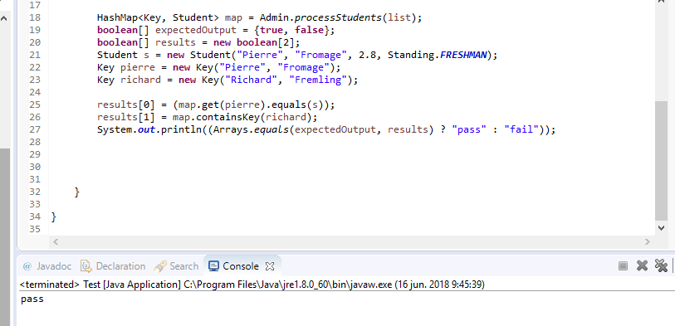

Problem 2

**package** prob2;

//DO NOT MODIFY IN ANY WAY

**public** **class** Employee {

**private** String name;

**private** **int** salary;

**private** String ssn;

**public** Employee(String name, **int** salary, String ssn) {

**this**.name = name;

**this**.salary = salary;

**this**.ssn=ssn;

}

**public** String getName() {

**return** name;

}

**public** **void** setName(String name) {

**this**.name = name;

}

**public** **int** getSalary() {

**return** salary;

}

**public** **void** setSalary(**int** salary) {

**this**.salary = salary;

}

**public** String getSsn() {

**return** ssn;

}

**public** **void** setSsn(String ssn) {

**this**.ssn = ssn;

}

@Override

**public** String toString() { //DO NOT MODIFY

**return** "(" + ssn + ": " + name + ", " + salary + ")" ;

}

@Override

**public** **boolean** equals(Object ob) {

**if**(ob == **null**) **return** **false**;

**if**(!(ob **instanceof** Employee)) **return** **false**;

Employee e = (Employee)ob;

**return** e.ssn.equals(ssn);

}

}

package prob2;

import java.util.ArrayList;

import java.util.HashMap;

import java.util.List;

public class EmployeeAdmin {

/**

Returns a list of Employees whose social security number is on the input list socSecNums

and whose salary is > 80000. The list must be ordered by social security number,

from lowest to highest. To sort, you must use a Collections sorting method

and you must define your own Comparator to be used to compare Employees by ssn.

*/

public static List<Employee> prepareReport(HashMap<String, Employee> table, List<String> socSecNums)

{

int SALARY=80000;

List<Employee> result= new ArrayList<>();

for (String ssn : socSecNums) {

if (table.containsKey(ssn))

{

Employee person= table.get(ssn);

if (person.getSalary()>SALARY )

{

result.add(person);

}

}

}

return result;

}

}

**package** prob2;

**import** java.util.Comparator;

**class** EmployeeComparator **implements** Comparator<Employee>

{

@Override

**public** **int** compare(Employee o1, Employee o2) {

**return** o1.getSsn().compareTo(o2.getSsn());

}

}

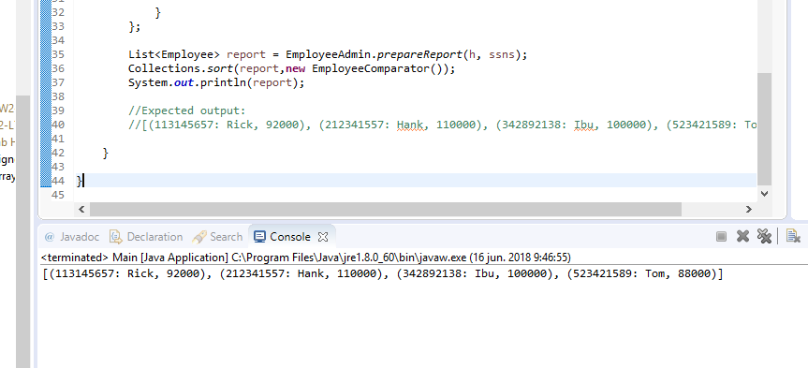

Problem 3

**package** Prob3;

/** NOTE: You must override equals in this class */

**public** **class** Employee {

**private** String name;

**private** **int** salary;

**public** Employee(String name, **int** salary) {

**this**.name = name;

**this**.salary = salary;

}

**public** String getName() {

**return** name;

}

**public** **void** setName(String name) {

**this**.name = name;

}

**public** **int** getSalary() {

**return** salary;

}

**public** **void** setSalary(**int** salary) {

**this**.salary = salary;

}

@Override

**public** String toString() {

**return** "(" + name + ", " + salary + ")";

}

@Override

**public** **boolean** equals(Object obj) {

**if** (**this** == obj)

**return** **true**;

**if** (obj == **null**)

**return** **false**;

**if** (getClass() != obj.getClass())

**return** **false**;

Employee other = (Employee) obj;

**if** (name == **null**)

{

**if** (other.name != **null**)

{

**return** **false**;

}

}

**return** **this**.salary==other.salary && **this**.name.equals(other.name);

}

}

